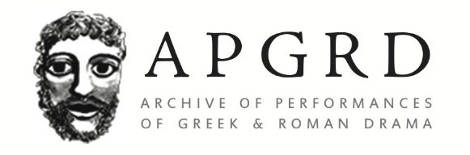

Newsletter 30
  - September 2021

‘Reopening’ the Archive
Huge thanks to everyone for bearing with us during the pandemic, and special thanks to those friends who made donations to the archive during lockdown. Your support of the APGRD and its aims - Research, Preserve, Create - are greatly valued and needed now more than ever. Remote working brought numerous challenges, but also opportunities that have allowed us to increase and diversify access to our resources. We established a Digital Resources section on our website, bringing together our multimedia/interactive ebooks, event recordings, podcast, and blog. We adapted events to deliver them online (including our seminars and public lectures, but also conferences, choreography workshops, film masterclass, and synchronised poetry recitals as well as hosting the transmission of the Oxford Greek Play (image below)), and we were able to invite speakers who would not normally be able to come to Oxford. We also increased our digital outputs and social media presence to keep in touch with the community of creatives and academics who fuel our research. In the coming year, we will continue our commitment to increased accessibility and inclusion, and to developing new, engaging digital outputs. As well as donations, we welcome any feedback or suggestions.
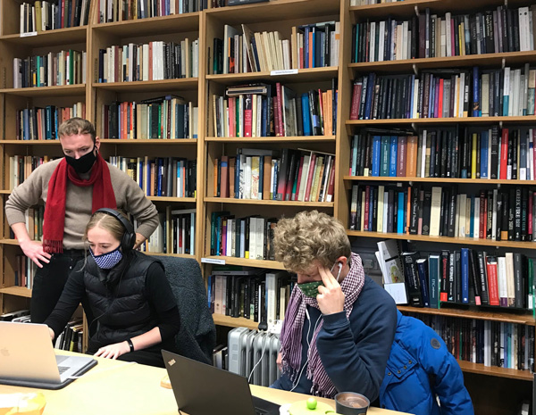

Congratulations to Estelle Baudou (APGRD Marie Skłodowska-Curie Fellow 2019-2021)
Congratulations to Estelle on the publication of her monograph Créer le choeur tragique. Une Archéologie du commun (Allemagne, France, Royaume-Uni, 1973-2010) (Classiques Garnier, August 2021). This important study interrogates how the concept of ‘commun’ – ‘what we have in common’ – is explored and critiqued through contemporary European performances of the ancient tragic chorus. A launch party will take place on Thursday 28 October. Estelle is continuing to work on her practice-based research on the translation and reception of ancient Greek texts in collaboration with Giovanna Di Martino (as part of the APGRD’s Translating Ancient Drama project). She is also collaborating with Anne-Violaine Houcke (Paris Nanterre) on Poetics, Politics and the Ruin in Cinema and Theatre since 1945, the second event for which will take place on 22 November 2021 at University of Paris Nanterre (see the events section below for further details of both the book launch and the conference).
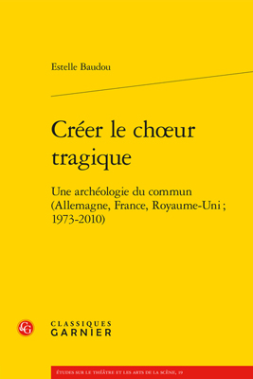

Congratulations too to Oliver Taplin
Congratulations to Oliver on the publication of his translation of Antigone, Deianeira, Electra which is due out as a World’s Classics paperback at the end of October.
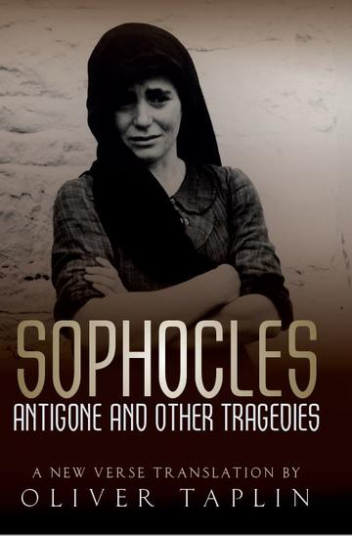

Finally, huge congratulations to both Felix Budelmann and to Edith Hall
Congratulations to Felix on his new post as Professor of Classics at the University of Groningen, and to Edith who will take up the Chair of Greek at the University of Durham in January 2022. We are delighted that both will remain as active members of the APGRD’s Advisory Board.

APGRD Podcast
We have continued to release new podcast episodes over the vacations, under the direction of Giovanna Di Martino and Claire Barnes:
- Episode 7: Classics in Communities with Arlene Holmes-Henderson and Mai Musié
- Episode 8: University Classical Plays with David Bullen and the 2021 Classical Play teams from Oxford and UCL
- Episode 9: Greek Tragedy and the Contemporary Actor with Zachary Dunbar and Stephe Harrop
- Episode 10: A Bread Factory with Mike Lippman and film director Patrick Wang
- Episode 11: Queer Andromeda with Hannah Greenstreet and Charlotte Vickers
You can access all episodes, and find links to subscribe to the series, from our Podcast page. The series will resume during the Christmas vacation.
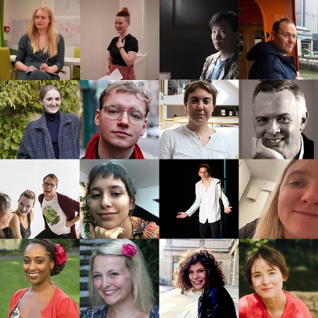

Martino Parra (University of Bologna, APGRD Erasmus intern) reports:
“Thanks to the Erasmus+ Traineeship programme, I had the great opportunity to spend two months at the APGRD as archivist-assistant. I worked with Claire Kenward and Claire Barnes who trained me in the use and maintenance of the APGRD’s electronic library catalogue, archive catalogue and performance database, and in the cataloguing and preservation of library items and archive materials. I also had the chance to assist with the publicity and organisation of academic events and the pleasure to help with the proof-reading of the APGRD’s multimedia EPUB version of Agamemnon, a performance history. Moreover, working in both the APGRD library and archive has helped me with the preparation of my PhD proposal on the Bacchae on the contemporary stage.”

APGRD Events
With the exception of our online seminar series, we look forward to welcoming you back in person to our public events this autumn. These events may of course be subject to sudden change or restrictions due to the pandemic; we will also aim to provide recordings and/or online access for those unable to travel to Oxford.

Reception Seminar, Autumn term 2021
Following last year’s success, this year’s Reception Seminar series will again be held online, over Zoom, on Mondays at 5pm. The theme is ‘Receptions and Comparatisms’ and it will be co-hosted with the British Comparative Literature Association (BCLA) and The Oxford Research Centre in the Humanities (TORCH), and with the support of the Oxford Comparative Criticism and Translation research centre (OCCT). For the full line-up of speakers and topics, see below; to register for the Zoom link, please email apgrd@classics.ox.ac.uk

Conferences and Colloquia

Poetics, Politics and the Ruin in Cinema and Theatre since 1945
22 November 2021. University of Paris Nanterre
This conference explores the ways in which artistic processes as well as works of theatre and cinema record the historical and artistic consequences of the Second World War in Europe by reinventing antiquity and by working with the ruin both politically and poetically. Organisers: Estelle Baudou (Oxford) and Anne-Violaine Houcke (Paris Nanterre).
Please email estelle.baudou@classics.ox.ac.uk with any queries or to register.

Poetic language: Greek and beyond

18-19 March 2022. Ioannou Centre, University of Oxford
A colloquium in honour of Michael Silk.
Organisers: David Ricks and Fiona Macintosh
Further details to follow.

Public Lectures, Autumn term 2021

The Glory and the Grandeur: John Clarke Stobart and the Defence of High Culture in a Democratic Age: a lecture by Chris Stray (Swansea)
18 October, 2pm. Lecture Theatre, Ioannou Centre, University of Oxford

Director/Dramaturg Tom Littler in conversation with members of the creative teams of Jermyn Street Theatre’s 15 Heroines and Odyssey
8 November, 2pm. Lecture Theatre, Ioannou Centre, University of Oxford

The poet A.E. Stallings will discuss and perform her work
29 November, 2pm. Lecture Theatre, Ioannou Centre, University of Oxford

Full APGRD Event Listings
Mondays, 5–6:30pm  (UK time)  Michaelmas Term 2021  Reception Seminar (Online)  Registration required, please email apgrd@classics.ox.ac.uk | Receptions and Comparatisms  Convenors: Fiona Macintosh (Oxford), David Ricks (KCL/APGRD Advisory Board Member) and Justine McConnell (KCL/APGRD Advisory Board Member)  - Week 1 (11 October): Disciplinarity: Emily Greenwood (Princeton) and María del Pilar Blanco (Oxford)  - Week 2 (18 October): Temporalities: Tim Rood (Oxford) and Adhira Mangalagiri (QMUL)  - Week 3 (25 October): What is a language?: Lucy Jackson (Durham) and Matthew Reynolds (Oxford)  - Week 4 (1 November): Orality and script worlds: Patrice Rankine (University of Chicago) and Haun Saussy (University of Chicago)  - Week 5 (8 November): Decolonisation: Phiroze Vasunia (UCL), Francesca Orsini (SOAS), and Chakravarthi Ram-Prasad (Lancaster)  - Week 6 (15 November): Decoloniality: Marchella Ward (Oxford), Mathura Umachandran (Cornell), and Joanna Page (Cambridge)  - Week 7 (22 November): Posthumanism: Clara Bosak-Schroeder (University of Illinois at Urbana-Champaign) and Alexander Beecroft (University of South Carolina)  - Week 8 (29 November): Anthropocene: Brooke Holmes (Princeton) and Ben Hutchinson (Kent)
Monday 18 October, 2pm  Lecture Theatre, Ioannou Centre, University of Oxford | The Glory and the Grandeur: John Clarke Stobart and the Defence of High Culture in a Democratic Age: a lecture by Chris Stray (Swansea)
Thursday 28 October, 5pm  Outreach Room, Ioannou Centre, University of Oxford | Book launch of Créer le Chœur Tragique (Classiques Garnier) by Estelle Baudou (Oxford)
Monday 8 November, 2pm  Lecture Theatre, Ioannou Centre, University of Oxford | Director/Dramaturg Tom Littler in conversation with members of the creative teams of Jermyn Street Theatre’s 15 Heroines and Odyssey
Monday 22 November 2021  University of Paris Nanterre | Poetics, Politics and the Ruin in Cinema and Theatre since 1945 conference. Please email estelle.baudou@classics.ox.ac.uk to register
Monday 29 November, 2pm  Lecture Theatre, Ioannou Centre, University of Oxford | The poet A.E. Stallings will discuss and perform her work
18 - 19 March 2022  Ioannou Centre, University of Oxford | Poetic language: Greek and beyond - a colloquium in honour of Michael Silk. Details TBC

@APGRD

