**Catullus in Song in Oxford**

Towards the start of 2023, St Hilda’s College welcomed playwright Stephen Sharkey, actor Jack Tarlton and musical director Alex Silverman to run the day-long workshop Catullus in Song. Here we present a selection of the poems that were translated and performed on the day, with some notes on Catullus in song by Stephen Sharkey.

“‘Latin is a dead language.’ Really? On Friday February 17, Catullus scholars, students from across the university, a playwright, an actor, a musical director, and several working poets gathered to disprove the tired cliché. Over the course of the day, we translated a hugely diverse selection of Catullus’ verse, from the raw to the raucous, the hate-filled to the heartfelt. We set them to music, to be sung, some accompanied by piano, guitar, or a simple lyre. Then as evening fell, translators became performers, taking to the stage of the JdP Music Building to breathe life into the lines of the most undead of classical poets. In the air of that intimate theatre, the passion, wit and artistry of Catullus rang out – very much alive.”

Stephen Sharkey

**Poem I. A Monologue for Four Voices**

*Catullus 1*

translated by Claire Barnes and performed by Daniel Whittle, Nathan Maybury, Cinna Mekonnen and Claire Barnes

**First voice**

**Second voice**

**Third voice**

**Fourth voice**

*Note: a ‘pause’ is longer than a ‘beat’*.

*The stage is strewn with crumpled texts. They have been tossed out for scrap; lost manuscripts waiting to be rediscovered.*

*All four voices walk out onto the stage. They each pick up a text, uncrumple it, sift through it, and sit down in a row on the stage facing the audience. They take their time. All make eye contact with each other to ascertain that they’re ready to start.*

*Throughout, the voices address each other; they finish each other’s sentences.*

**First voice:** Who wants it?

**Second voice:** My little book-

**Third voice:** *(interrupts)* My GAY little booky-wook.

**Fourth voice:** Buffed; hot off the press.

*(Beat)*

**First:** I know *you* want it, Cornelius.

**Second:** You used to think my shit chat-

**Fourth:** -was *lit* chat.

**Second:** When you wrote not one

**Fourth:** Not two

**First:** But *three* weighty tomes.

**Third:** Fuck me, what a slog.

*(Pause. Tonal shift.)*

**First:** Please. Take my…little scribbles.

*(Beat)*

**Third:** It would mean the world.

**Birdy**

*Catullus 2* and *Catullus 3*

translated Daniel Whittle and Nathan Maybury and performed by Cinna Mekonnen

Hold me, cradle me

Tease me, please me

Desire me, distract me

Feel me…

I know what your heart wants,

I know where your mind is drifting

A dactyl beat, just one beat…

*I could almost cry,*

*The sparrow is limp,*

*It was helped and cradled,*

*My love’s desire,*

*But it went through that dark tunnel*

*To rise again?*

Appease my requests, respond to my distress

Take away my pain

Lift my spirit

Play with me,

Your little Birdy.

**A Bit of a Tart**

*Catullus 10*

translated by and performed by Maureen Almond

He took me as a bit of a tart  
said I was not beautiful – more sort of pretty.  
Cheek, he’s no oil painting!  
But then we got talking,  
about Brexit of all things.  
He told me straight out,  
‘bet you’ve made a mint have you?’  
Well I had to be honest,  
‘No body’s become richer following this shambles –  
the foreign market’s gone down the pan,  
especially when your pimpy boss is an arsehole’  
  
He obviously sees me as lucky  
despite the fact that I work a crappy patch.  
So I begged him, ‘send your spare men to me,  
then take me to church – I need church’.  
He said, ‘well they’re not my men,  
not really – but so what,  
I treat them as mine.  
You would catch me out wouldn’t you –   
you bloody would!’

**Poem XXII Part 1**

*Catullus 22*

translated by Claire Barnes and performed by Daniel Whittle, Nathan Maybury, Cinna Mekonnen and Claire Barnes

*All four voices assemble, they start speaking before they’ve sat down. Addressing each other, as before.*

**Third:** *(exasperated)* Suffenus…!

**Fourth:** *(also exasperated, leaning forward to address another)* Oh come on Varus, you know *exactly* who I’m talking about.

**First**: He’s a good-looking guy, I’ll give him that.

**Second:** Silver-tongued

**Third:** Silver *fox*…

**Second:** Well, word on the street is that very same Suffenus has a *huge-*

**Fourth:** *(quickly) -*body of verse. To his name.

*(Pause)*

**Third:** I reckon he must have written…ten thousand poems.

**First:** Maybe even more.

**Second:** And he’s not like the rest of us…oh no…

**Third:** He doesn’t scribble them down in notebooks…

**Fourth:** ...on the back of receipts…

**First:** ...on beer mats, whenever the muse strikes…

**Second:** *He* types them up in Garamond

**Third:** on his Macbook Air

**Fourth:** front and centre in the most hipstery joint in town.

**First:** He circulates them at gallery openings, he confects them into zines…

**Third:** He humblebrags about them on *fucking Twitter*…

*(Pause)*

**Second:** But the thing is, Varus. *The thing is…*

*(Pause)*

**Fourth:** I’ve shat better poetry than his.

**Poem XXII Part 2**

*Catullus 22*

translated by Claire Barnes and performed by Daniel Whittle, Nathan Maybury, Cinna Mekonnen and Claire Barnes

**Second voice:** Suffenus…

**Fourth voice:** *Suffenus*…

**Third voice:** He writes like someone stuck a silverback gorilla in front of a typewriter.

*(Pause)*

**First:** *(bitchily)* He’s from Berkshire, you know.

**Second:** *(horrified)* Berkshire!

**Fourth:** When’s the last time anything approximating vivacity came out of fucking *Berkshire..?*

*Third voice picks up the lyre. They take their time. All the other voices fall silent and watch.*

*Third voice* *stops playing, looks up and addresses the audience.*

**Third:** *(wryly)* Oh, who am I kidding… This shit’s hard.

**The Whole Nine Yards**

*Catullus 32*

translated and performed by James Methven

O, pretty please

*O pretty, please*

O, pretty please

*O pretty, please*

My sugar-syrup Sangria

My runny sunny delight

My charmant—

Deliveroo me as a lunch-hour morsel

Uber eat me as a tasty titbit

*Deliveroo me as a lunch-hour morsel*

*Uber eat me as a tasty titbit*

Sluice your diary

Prep the table

Clear your deck

Leave your front and back doors open

Play stay-at-home

Get yourself wet

For

One of my famous

Nine-inch fu-u-u-u-un snuggles

O pretty pretty, O pretty pretty, O come come, O quickly come come,

Come come, O quickly come come,

Quickly come come, O

Tell daddy when to come—

I’ll take the blue pill and necromance

A bulge right through my Gucci pants.

With thanks to Alex Silverman

**Take My Tablets**

*Catullus 50* and various

translated and performed by Cinna Mekonnen

take my tablets, fold them in hand-warmth

metre to metre free flow

echo to echo of echo of echo

through till the walls cave we keep finding each other in

ink blots and runs and weighs down paper

sprawling wits no polish

turning trash to kindling

fire between my teeth turns

voice singing through me

lost to her; in time i'll

star-cross my mired eyes and hope to die, see

dawns rise and sink and i see no light, toss-

turning, in darkness, world stops turning,

world we grew you slashed and burned

without a word from you

**You Make a Nice Pair**

*Catullus 57*

translated and performed by Chris Leckey and Jemima Freeman

You make a nice pair, you absolute manwhores,

Cabinet's top Johnson’s Cumming cocks in hand,

Matching permanent stains for plebs to scrub,

Skidmarks down the Appian Way,

STD superspreaders, equally riddled,

Two pedant pricks on one bottom bunk, you no less than you,

Gagging for a fuck, cocks in hand, johnsons cumming,

You make a nice pair, you absolute manwhores.

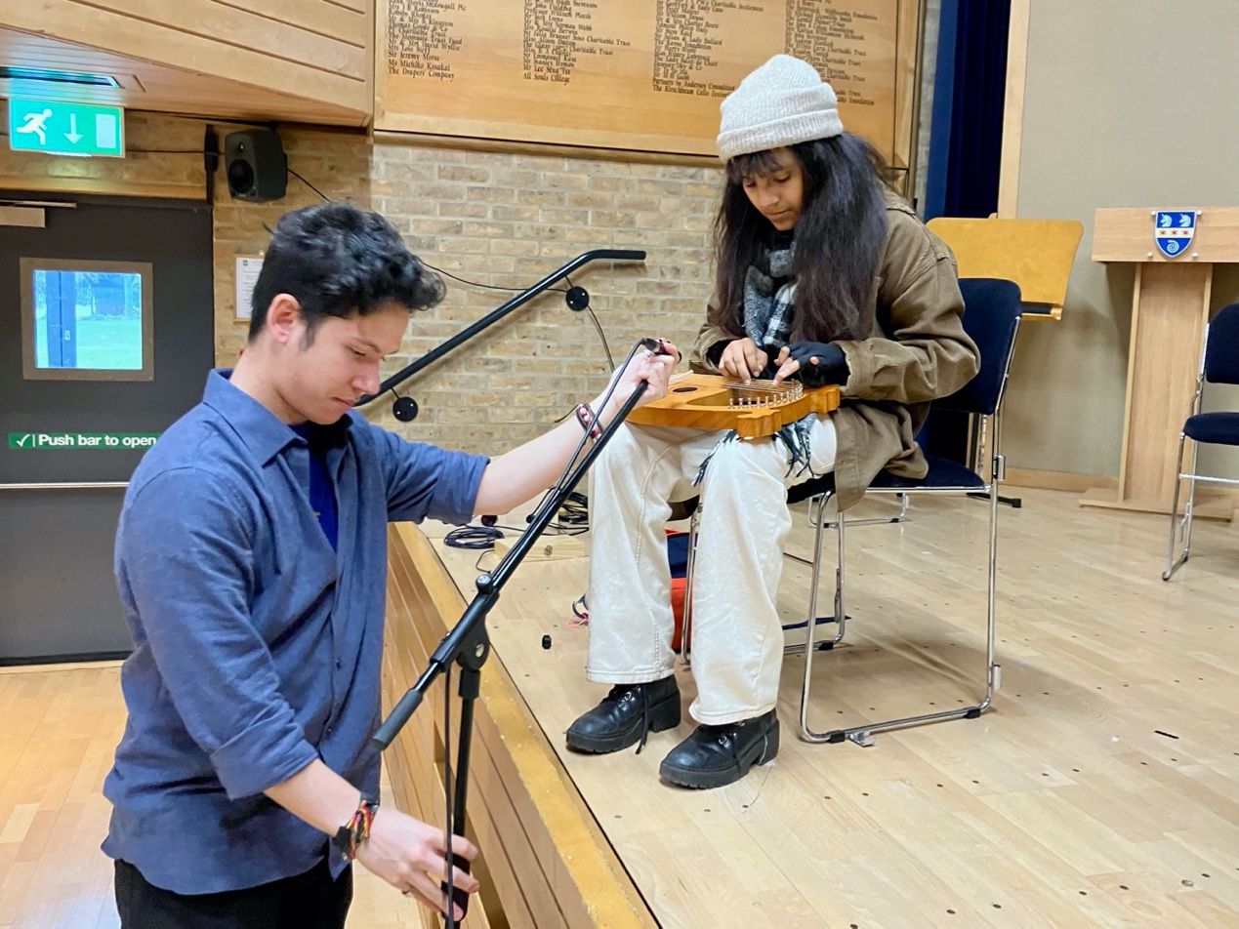

Franco Lopez and Cinna Mekonnen

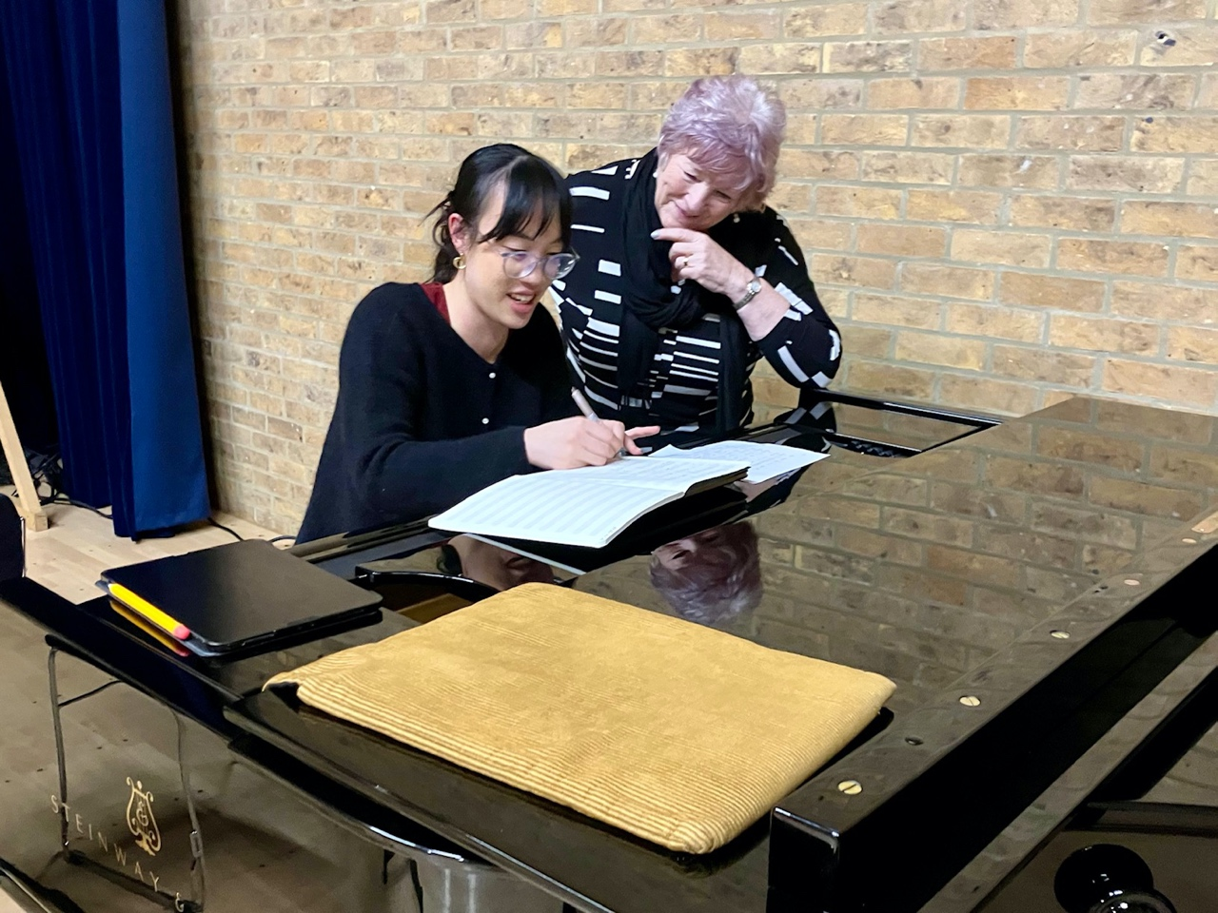

Cynthia Liu and Maureen Almond